-6l~162zl

S O U T H W E S T R E S E A R C H I N S T I T U T E:
Department of Fire Technology
POST OFFICE DRAWER 28510, 6220 CULEBRA RD. SAN ANTONIO. TEXAS 782B4

INVESTIGATION OF SURF ACE BURNING CHARACTERISTICS OF:
A FIRE-RETARDANT COATING:
CLEAR FIREPOLY (3D-MINUTE TEST)

PROJECT NO. 01-8302-454
FINAL REPORT
SEPTEMBER 3, 1985
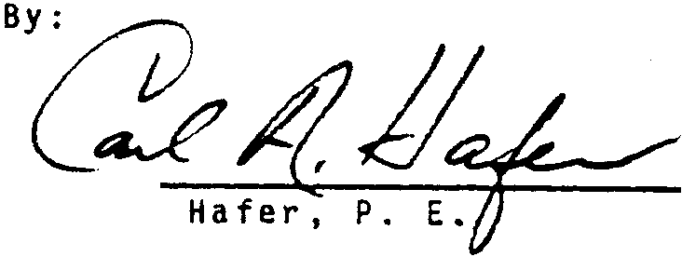
Approved by:
Or. Gordon E. Hart 1
Director, Fire Technology for

Dr. Robert E. Lyle Vice President Chemistry and Chemical Engineering
Ca r 1 A. Manager
Standard Testing Services

S O U T H W E S T
R E S E A R C H
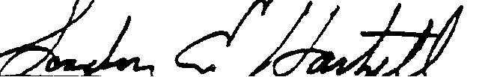
I N S T I T U T E

This report presents the results of a flame spread tunnel test on a fire-retardant coating t submitted for eva1uation by Machemo Corporation of Fort Worth_{t} Texas. The report contains a description of the materia1 tested t the preparation and conditioning of the specimen t the test procedure, and finally, the test results. Note that the results only apply to the specimen tested, in the manner tested, and not to the entire production of this or similar materia1s_{t} nor to this materia1's performance when used in combination with other materials. All test data are on file and are available for review by authorized persons.
The test was conducted in accordance with the provisions of ASTM Designation E84-84_{t} "Standard Method of Test for Surface Burning Characteristics of Building Materials." This test method is similar to the test method specified in ANSI No. 2.5, NFPA No. 255, UL No. 723, UBC No. 42-1. ASTM E84 is a test procedure method only and does not set requirements for materials. Therefore, SwRI does not assign a classification to the material tested. Building codes, such as the Uniform Building Code, have requirements dependent on building type occupancy, etc. The building code having jurisdiction in the location a material is to be used will determine compliance of the test results. The Client requested that the test be continued for 30 minutes although the ASTM E-84 test is 10 minutes.
The purpose of the test was to evaluate performance of the test specimen in relation to that of glass-reinforced-cement board and red oak flooring under similar fire exposure. The results are expressed in terms of f1ame spread, fuel contribution, and smoke developed during a 10-minute exposure and are recorded as a rati0 with glass-reinforced-cement board O and red oak flooring 100.
II. DESCRIPTION OF MATERIALS
On July 23, 1985, the test material was received from the Client.
It is described in Table 1 on the following page.
I. INTRODUCTION

SwRI Project No. 01-8302-454 2 22
TABLE 1. DESCRIPTION
Type:
Trade Name:
Color:
No./Size Received:
Total Weight:
Unit Weight:
Substrate Used:
Clear fire-retardant coating MACHEMCO Clear FirePoly
Clear
One 5-ga 1 can
48.2 lb (21.88 kg) (Container not full)
10.46 lb/gal (1.25 kg/L)
Tongue and grooved Douglas fir wood
III. PREPARATION AND CONDITIONING OF TEST SPECIMEN
The 21-in. x 25-ft (0.53 x 7.63-m) specimen was prepared using two 21 x 150-in. (0.53 x 3.81-m) decks prepared of 1 x 4-in. (25.4 x 101. 16-rrm) tongue and grooved clear Douglas Fir wood flooring. Each deck was held together using wood straps 0.5 x 4 in. (12.7 x 101.16 mm) at four locations. The coating was applied by high pressure spray by Mr. Dennis Lunsford. The net coverage was 1.353 oz/ft² or 124 ft²/gal (3.07 m²/L).
The specimen was conditioned for 17 days in an atmosphere maintained between 68 and 78°F (20 and 26°C) temperature and 45- to 55-percent relative humidity.
IV. TEST PROCEDURE
The test was conducted on August 9, 1985. Reference data were
obtained and furnace operation checked by conducting a 10-minute test
with glass-reinforced-cement board on the day of the test and by periodic
tests with red oak flooring. These tests provided the 0 and 100 references
for flame spread, fuel contribution, and smoke developed. Ignition over
the burners was noted 40 seconds after the start of the test in the most
recent calibration with red oak flooring. Each specimen to be evaluated
was tested in accordance with the standard procedure except the test on
the fire-retardant coated wood was continued for 30 minutes.

SwRi Project No. 01-8302-454
V. TEST RESULTS
The test results were calculated on the basis of observed flame travel and the measurement of areas under the recorder curves of furnace temperature and smoke developed (see Table 2). To allow for possible variations in results due to limitations of the test method, the numerical results were adjusted to the nearest figure divisible by 5.
Recorded data for flame spread, fuel contribution, and smoke developed for the specimen are shown in the figures at the end of this report as a solid line on each graph.
TABLE 2. CLASSIFICATION
Test Specimen
Flame Spread Index
E84-84
Fuel Contribution
Smoke Developed
Glass-Reinforced-Cement Board Red Oak Flooring
A Fire-Retardant Coating:
MACHEMCO Clear FirePoly (10 Minutes)*
o 100
o 100
o 100
20
15
140
*Flame front advanced to 24.5 ft at the end of the 30-minute test exposure.
VI. OBSERVATIONS DURING AND AFTER TEST
Observations made during and after the test are presented in Table 3 below.
TABLE 3. OBSERVATIONS
Event
Discoloration, min:s Steady Ignition, min:s Cracks, min:s
0: 11 1:10 3:45

SwRI Project No. 01-8302-454
TABLE 3. OBSERVATIONS (Continued)
Event (Continued)
Maximum Flame Front Advance, min:s
9:00
12 (3.66)
ft
(m) Afterflame, min:s
**
Damage (After 30 Minutes)
1/4-In. Char Intumescence, ft 20 to 25
(m) (6.10 to 7.63)
Char Depth of Wood, 1/4 in., ft
(m)
Heavy Char, ft
(m)
20 (6.10) 25 (7.63)
**At the Client's request the test was continued, with fuel on, for 30 minutes. The wood burned through at approximately 25 minutes. The flame front advanced to 24.5 ft (7.42 m) at 27 minutes 45 seconds without reaching the end, 25 ft (7.63 m), during the 3D-minute test. Pieces of wood began falling at 29 minutes. The flame advance, temperature rise at 24 ft (7.32 m) and smoke developed during the 30-minute test are shown in the graphs at the end of the report.






  



